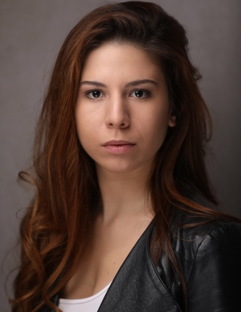
Eleonora Kouneni
Age range: 18-30
E-mail: eleonora.kounf@gmail.com
Spotlight Pin: 8133-8970-6384
Mandy.com profile: https://www.mandy.com/actor/profile/eleonora-kouneni
Website: https://www.eleonorakouneni.com/
YouTube/Instagram/Twitter: Eleonora Kouneni

Measurements

Height, 5.2’’ (1.57cm); Dress, UK 8-10; Shoes, UK 4-4½; Bust, 34’’ (86cm); Waist, 29’’ (74cm); Hips, 39’’ (99cm)

Credits

2020
7 Different characters – Date Or Mate (Short film) - Director, Krysianna Papadakis – In production
2019
Millie – Election Night (Feature film) - Director, Neil Monaghan
Candy Swirl – 4 Kingdoms Magical Christmas Experience (Immersive Theatre), 4 Kingdoms
Busker – Photofoxx app (Commercial) - Director, Gabi Carpenter
2018
Female Lead – Taboo (Online release - Film, short) - Director, William Mann (https://www.youtube.com/watch?v=E3PmrNgN2lA)
Dalihah – The First Time (Film, short) - Director, Bim Ajadi
2017
Lead girl – Suppa Sass / My Cussen (Music video) - Boo Tv
Victim – CHNOPS - BigBang Films
Roxy – UNSUBSCRIBE (Episodes 1, 9 - Web series) - Director, Andrew Southern
Rachel – I Can’t Live Without You (Commercial) - DONROY ENTERTAINMENT LTD
Marge – Cynthia’s not in (Student Film, Short) - Director, Kevin Dorian
2012
Ginny Jenny – The Threepenny Opera (Theatre) AFANTOI Theatre Company (Athens, Greece)
Ice skater – "Fear on Ice" στο Allou! Fun Park! – Commercial, Allou! Fun Park!
2010
Hermia – A Midsummer Night's Dream (Theatre) – AFANTOI Theatre Company (Athens, Greece)

Education/Training

2019
Morley College
Tap Dancing for improvers (6-month course)
Drumming for beginners (3-month course)
CityLit
Sing the Blues (12-week course)
Jazz vocal improvisation (12-week course)
2018
Acting With Method – Advanced screen acting Master Class (38 h over 5 weeks)
Gravy for the Brain (online) - 24h of Professional Voiceover Training
CityLit
Screen Acting: Improvers (12-week course)
Morley College
Tap Dancing for beginners (6-month course)
Jazz Dancing General (year-long course)
Jazz Singing Workshop 1 (year-long course)
Piano grade B (year-long course)
2017
CityLit
Screen Acting: Beginners (Extended) (12-week course)
An actor prepares (12-week course)
Stanislavski: Beginners (6-week course)
Morley College
Jazz Dancing: General (year-long course)
Introduction to dance: Ballet, Contemporary & Jazz (1-day workshop)
Acting for Screen (8-week course)
Introduction to acting (8-week course)
Actors Studio, Pinewood
1-Day Screen Acting Workshop
2013- 2014
Universidad de Castilla La Mancha – English Literature and Drama (Spain, semester abroad)
2010- 2015
National and Kapodistrian University of Athens – English Literature and Drama

Skills
Professional Jazz Singer/Songwriter; Guitar (Advanced); Piano (intermediate); Photographer; Ice skating (Intermediate); Basketball (Advanced)
Languages: Greek (native), English & Spanish (fluent/qualified to teach)
Accents: In English: RP, London, Yorkshire, American-California, American-Standard, Cockney, English-Standard, Greek, Italian, French, Spanish, Latin American;
In Greek: Greek, English;
In Spanish: Spanish (Madrid), Mexican, Cuban

